Location of Hampton Wick Cricket Club

By car
The Hampton Wick Cricket Club is in Park Road, Hampton Wick, close to Kingston Bridge.
- Come to the mini roundabout at the foot of Kingston Bridge.
- Take the A308 in the direction of Staines and Hampton Court.
- Take first turning on right into Church Grove.
- Keep the park wall on your left as the road bends left.
- At the next corner, as the road bends right turn left through green gates into Hampton Wick Cricket Club.

By train
The nearest station is Hampton Wick, approx 25 mins from Waterloo. Service every 15 mins.
- Down the steps from the platform, turn left past ticket office.
- Cross over High Street and turn right. Walk 10 yards or so and turn left into Vicarage Road.
- Walk to the end of Vicarage Road. Turn left where it meets Sandy Lane/Park Road.
- Cross Park Road by red pillar box on corner.
- Walk through green gates into Hampton Wick Cricket Club

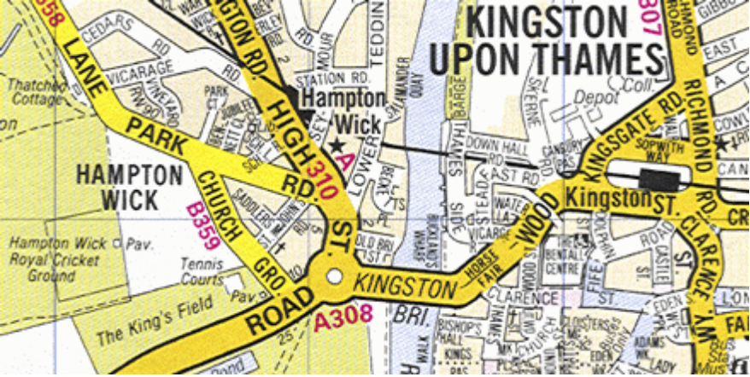
Entrance
Staines
Hampton Court

